GRANDE CABANE d’ ILLINOIS

Femme

OFFICIAL CALL
FOR THE FALL CHEMINOT
BLOOMINGTON, ILLINOIS
OCTOBER 30 and 31, 2026

Dames,
I want to thank all the Dames for having the confidence in me to perform the duties of Madame Presidente. Please, if you have any questions on the programs that we are working on, do not be afraid to ask if I cannot answer at the time I will find out. I would also ask that you have a report on your program, which is how everyone learns what we do. Hope to see you at the Fall Cheminot in Bloomington.

La Grande Presidente, Jane Harmon

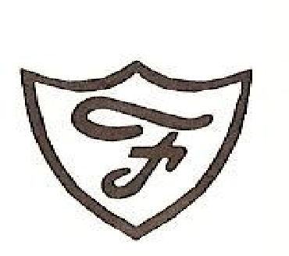
This is the OFFICIAL CALL for the FALL CHEMINOT on October 31st, 2026. We will meet at Crossroads Chapel, 1049 JC Parkway, Bloomington. Holiday Inn Express, 1031 Wylie Drive, Bloomington, IL 61704, 309/820-9990. Make your own reservations.

La

Societe

de

FALL GRANDE CHEMINOT SCHEDULE:
Friday, October 30, 2026
4-5 pm – Registration at motel.
Saturday, October 31, 2026
9:30-10:00 am- LaFemmes Registration at Crossroads Chapel
10:00 am - Business Session
Will break for lunch at noon. Luncheon info to come later 2nd Business Session if needed after the luncheon.

CORRESPONDANTES LOCALE: Please bring me an up-to-date list of members, address, phone, and e-mails and remember two (2) copies of your report. Thank You, Odie, Grande Correspondante.
Ways and Means will be giving the $100.00 to the first name drawn. Also bring gifts for the rest of the names to be drawn. The more gifts we give away the more tickets we can sell. Please sell as many tickets as you can. Please think in and out of the box on how to raise money.

Jane Harmon Odie Ales
La Grande Presidente La Grande Correspondante

