
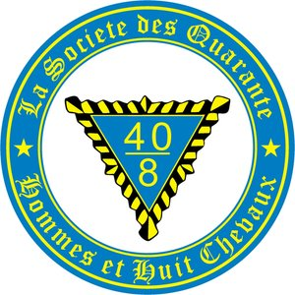

Grand Promenade

Friday July 24th thru sunday july 26th 2026
Block available until the 17th
Quality Inn
200 Gore Road Morris Illinois 60450
815-416-9239
$94 per night plus tax
Friday Taco/Nacho Bar 7PM $15
Friday night live music / open mic in The Pub
Saturday Cocktail hour 5PM Prime Rib $30
Wrist Band to be on the tab for drinks $20
Registration $20
RSVP/PREPAY TO: Robert Dettmann 815-514-6873
709 Joanne Drive Minooka Illinois 60450
Please Make Checks Payable to: 40 et 8 Voiture 1195

