Shrine of Democracy Dakota 40 ET 8 er
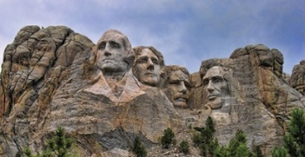
La Société des Quarante Hommes et Huit Chevaux
Grand du South Dakota Voiture 180
Mc Cook, LINCOLN and Minnehaha Counties South Dakota
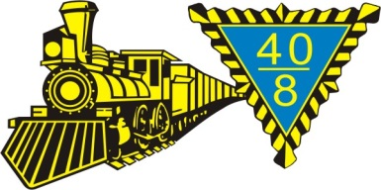
“Service during War Charity during Peace”
6505 W. Westminster Dr. appiolson@gmail.com
Sioux Falls, SD 57106 605 362 5825 / 605 661 7839
February 2026 2nd EDITION

AMERICANISM - CHILD WALFARE - VAVS - BOX CAR ASSN. - NURSES SCHOLARSHIPS - POW/MIA – CARVILLE – POW/MIA – YOUTH SPORTS

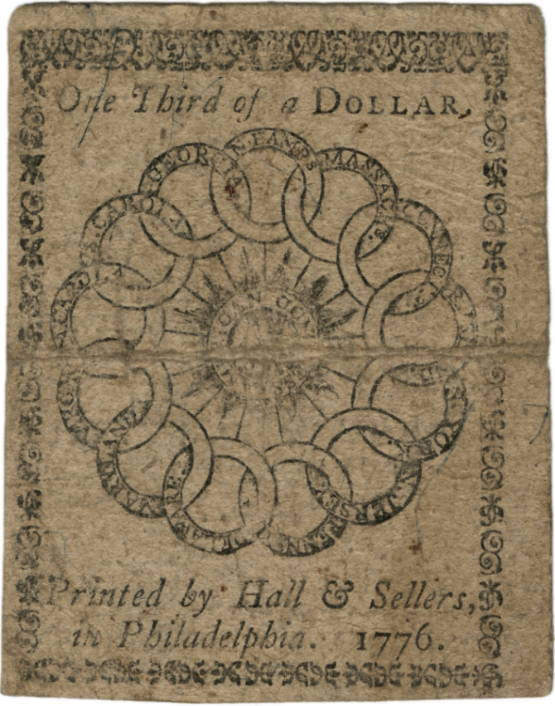
This one-third dollar note, issued in February 1776, displays a linking ring or chain of states and sunburst design which reads: "AMERICAN CONGRESS WE ARE ONE." (MVLA) (250 years ago)

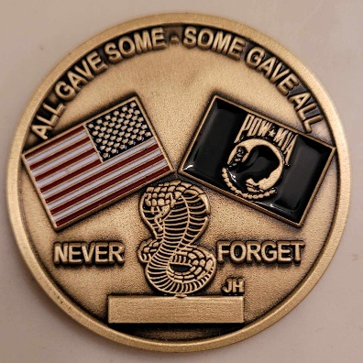

IMPORTANT EVENTS AND
BATTLES IN 1775

APR The first shots of the war fired at Lexington
and Concord.

MAY Second Continental Congress
assembles in Philadelphia.

JUNE Battle of Bunker Hill.

JULY Washington takes command
of Continental Army.

AUG George lll Proclamation of Rebellion.

DEC Parliament passes Prohibitory Act.

ENGLISH LANGUAGE

The most commonly used language in the United States is English (specifically American English), which is the national language and de facto official language. While the U.S. Congress has never passed a law to make English the country's official language, the federal government primarily uses English and a 2025 executive order declared English official. In addition, 32 U.S. states out of 50 and all five U.S. territories have laws that recognize English as an official language, with three states and most territories having adopted English plus one or more other official languages. Overall, 430 languages are spoken or signed by the population, of which 177 are indigenous to the U.S. or its territories.
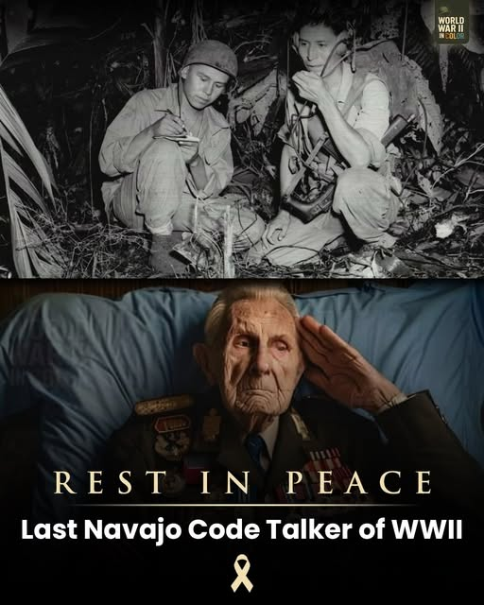WW ll CODE TALKER
It is with profound sorrow that we bid farewell to John Kinsel Sr., one of the last surviving Navajo Code Talkers, who passed away at the age of 107. From Bougainville and Guam to Iwo Jima, he spoke a sacred language transformed into an unbreakable code — confounding the enemy, safeguarding vital operations, and helping
secure victory in the Pacific. His words protected count-less lives, even as so many of his brothers in arms never returned home. His service was quiet. His impact was immeasurable. Today, we honor not only his extraordinary life, but also the thousands who fell in the battles his messages helped guide — Marines, sailors, and soldiers whose sacrifices are forever tied to his voice.
Though his voice has fallen silent, his legacy — and theirs — will echo through generations.
Rest in honored peace, Code Talker.
Your words helped change history.

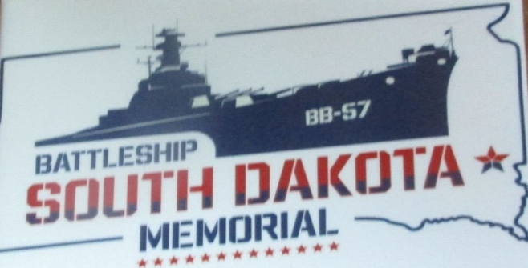
Open May 1st to September 30th
(605) 367-7141

40 and 8 FLAG PROGRAM 2
BERESFORD, SD 4TH GRADERS
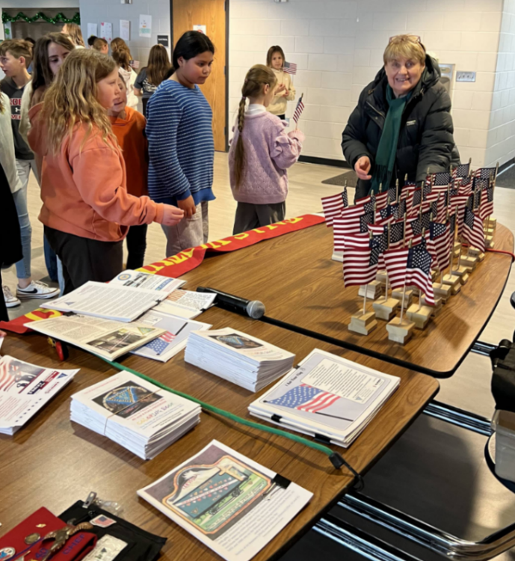
40 and 8 La Femme Iryna Olson prepares flags and literature for the 50 4th grade students at Beresford, SD Elementary School Friday February 6, 2026.
The flag-folding ceremony represents the same religious principes on which the United States was originally founded.
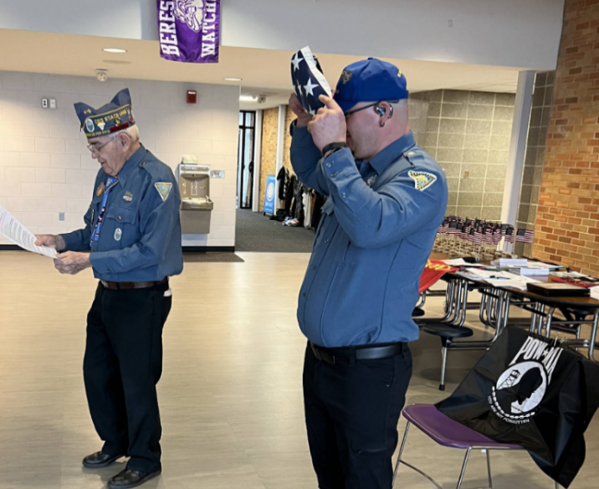
The last fold, the 13th when the flag is completely folded, the stars are uppermost, reminding us of our national motto, “In God We Trust.” It also now has the appearance of a cocked hat, reminding us of General George Washington. As Voiture Preston Olson reads the 13th fold, Voiture Jesse March shows the cocked hat to the students.
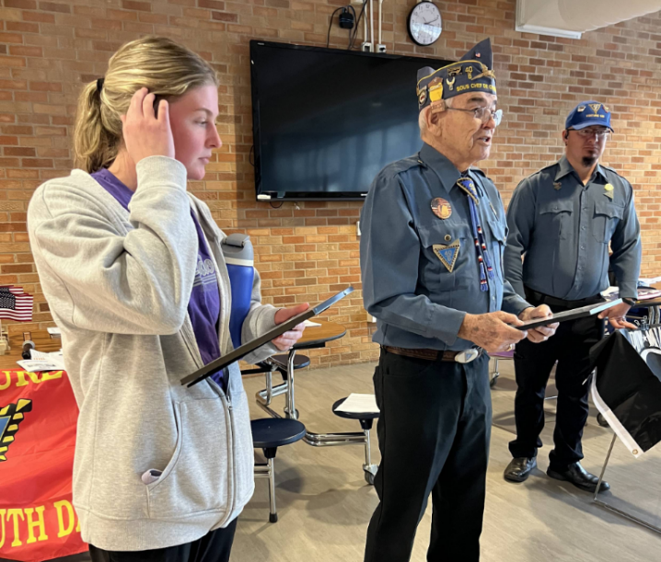
Voyageur Olson has presented Bersford 4th Grand Teacher Brook Klien a certificate of appreciation for inviting Voiture 180 to present the 40 and 8 FLAG PROGRAM to her class. We also presented 4th Grade Teacher Scott Ebert and Principal Troy James with framed certificates. Voyageur March is in background.
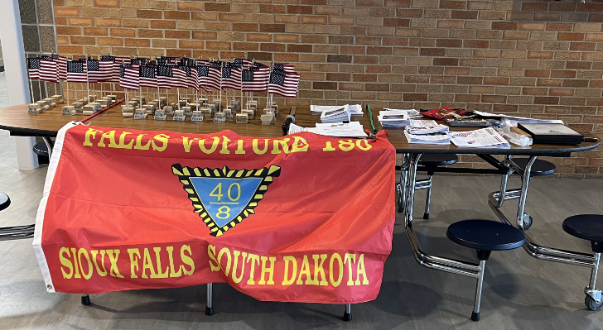
Table with flags and 40 and 8 FLAG PROGRAM Literature at the Beresford Elementary School.
ARLINGTON NATIONAL CEMETERY
Although Arlington National Cemetery (ANC) was established long after the death of George Washington, the legacy of the nation’s first president holds a special place here. On Washington’s birthday during the nation’s 250th anniversary year, it is appropriate to share those connections.
The land that became ANC had previously been a plantation owned by George Washington Parke Custis, Washington’s step-grandson. Custis intended Arlington Plantation to serve as a memorial to President Washington, filling the house with items that belonged to George and Martha Washington. Custis also brought enslaved people, which he had inherited from his grandmother, Martha, from Mount Vernon. 3
In the decades after ANC’s creation, the remains of numerous veterans of the American Revolution were reinterred here. Among them was Pierre L’Enfant (Section 2), a French officer who served with Washington at Valley Forge. After the war, Washington chose L’Enfant to help design the new nation’s capital.
Washington’s memory also lives on at
ANC’s Memorial Amphitheater, where his name is inscribed at the top of a list of renowned generals. A famous quote from Washington’s 1775 speech to the New York Provincial Congress is prominently engraved above the stage: “When we assumed the soldier, we did not lay aside the citizen.” Visible during national observances and somber ceremonies, Washington’s quote is a reminder that the service members buried at ANC were citizen soldiers who carried on his legacy.
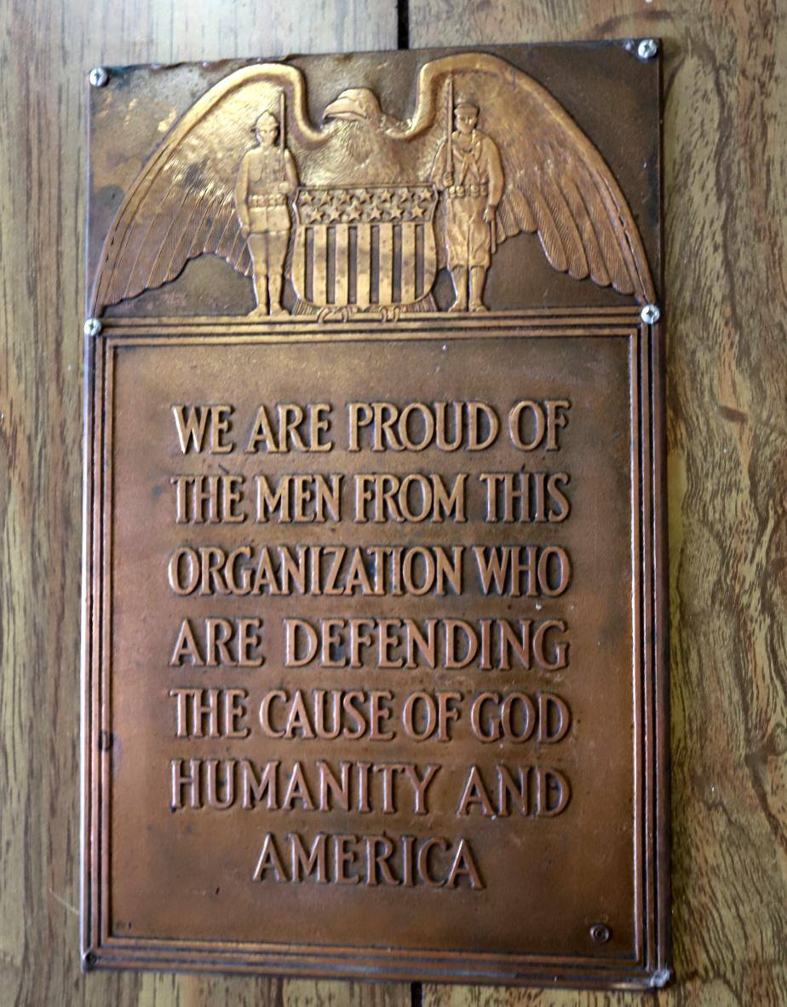
LA SOCIETE

“It is to be regretted that the rich and powerful to often bend the acts of government to their own selfish purposes.”
Andrew Jackson
I could add that this happens in organizations also, Mr. Jackson.
PRO

Call to Spring Cheminot VL 773:
Watertown SD Location/Host Voyageurs and La Société de Femmes South Dakota 40 & 8
From Jim Payne,
Grande du SD Correspondant;
jim_payne_sd@hotmail.com
By order of the Grand Chef de Gare, Allan Ochsner, the call of Spring Cheminot, 2026 of the Grande Voiture du South Dakota, La Société des
Quarante Hommes et Huit Chevaux is hereby made, March 27th and 28th,
2026. The Spring Cheminot will be hosted by 773 Watertown, SD, Cheminot will be Saturday 0840, at the American Legion, Post 17. Registration $60.00 (includes the cost of lunch, evening banquet).
Cheminot starts at 0840 hrs. Lodging:
Quality Inn and Suites, Watertown SD.
Phone number is: 605-886-3010. When making reservations say you are with
the 40&amp;8 Group. These need to be reserved by March 12th, Carl Killion asks
that you RSVP him, his phone number 605-881-0475. A steak dinner is on the menu for the Saturday evening meal. Possibly, Homemade Caramel rolls and
coffee will be served Saturday morning. All events will be held at the
American Legion Post 17, located at 1412 9th Ave SW #5091, in Watertown.

PURPOSE:
The Spring Cheminot is called for the following purposes but not limited to
upon presentation of; To consider any other business for the Good of the
Grande Voiture which may come before the assembly. The following committees will start meeting at 8:40 am: Nominations committee,

Constitution and by laws, Ritual 4
and Awards. Chef Ochsner has also called
on all Voiture Locales candidates for directeurs and officers. Upon completion
of meetings, Cheminot will immediately follow.

REPRESENTATION 4
All Grand Chefs de Gare Passe of the Grande Voiture Du South Dakota while in good standing in their respective Voiture Locale, all Grande du South Dakota officers, directeurs and Voyageur’s Militaire are asked to attend.
Nationale, Grande officers, directeurs and locale Chefs or representative of
locale voitures are asked to give a short report of activities.
CREDENTIALS:
No individuals are allowed on the floor of the proceedings without being
qualified Voyageurs Militaire.
BY ORDER OF THE GRAND CHEF DE GARE Allan Ochsner
Committee Chairs:
Nominations Committee Chair:
Preston Olson
Constitution and Bylaws Committee
Don Fuller
Box Car Committee Chair:
Allan Ochsner
Ritual and Awards Committee Chair:
Greg Hall
If you are a committee chairperson, and will not be attending, let Chef Ochsner or myself know, and a replacement will be named.

The diligent Stars and Stripes waved on
Through the long and pounding night,
While patriots prayed that they would see
Their flag at mouning light.
*From a boat in Baltimore Harbor, Francis Scott Key observed the British bombing of Fort McHenry in the War of 1812. During the night, he saw only glimpses of the American flag through the smoke and flares of light. The next morning, he was so happy to see the flag still flying that he began writing a poem. Later, this poem was put to the tune of another song and became America’s national anthem. “The Spangled Banner.” * The flag that inspired “The Star Spangled” was made by Mary Pickersgilland her daughter, Caroline. It measured thirty feet by forty-two feet. TODAY, that restored flag is on display at the Smithsonian Institution in Washington, D.C. * From “The Flag We Love by Pam Ryan

ARLINGTON NATIONAL CEMETERY
Although Arlington National Cemetery (ANC) was established long after the death of George Washington, the legacy of the nation’s first president holds a special place here. On Washington’s birthday during the nation’s 250th anniversary year, it is appropriate to share those connections.
The land that became ANC had previously been a plantation owned by George Washington Parke Custis, Washington’s step-grandson. Custis intended Arlington Plantation to serve as a memorial to President Washington, filling the house with items that belonged to George and Martha Washington. Custis also brought enslaved people, which he had inherited from his grandmother, Martha, from Mount Vernon.
In the decades after ANC’s creation, the remains of numerous veterans of the American Revolution were reinterred here. Among them was Pierre L’Enfant (Section 2), a French officer who served with Washington at Valley Forge. After the war, Washington chose L’Enfant to help design the new nation’s capital.
Washington’s memory also lives on at ANC’s Memorial Amphitheater, where his name is inscribed at the top of a list of renowned generals. A famous quote from Washington’s 1775 speech to the New York Provincial Congress is prominently engraved above the stage: “When we assumed the soldier, we did not lay aside the citizen.” Visible during national observances and somber ceremonies, Washington’s quote is a reminder that the service members buried at ANC were citizen soldiers who carried on his legacy.
Thomas Jefferson
Of all the duties imposed on the executive head of a government, appointment to office is the most difficult and most irksome.
From the book: “THOMAS JEFFERSON IN HIS OWN WORDS”

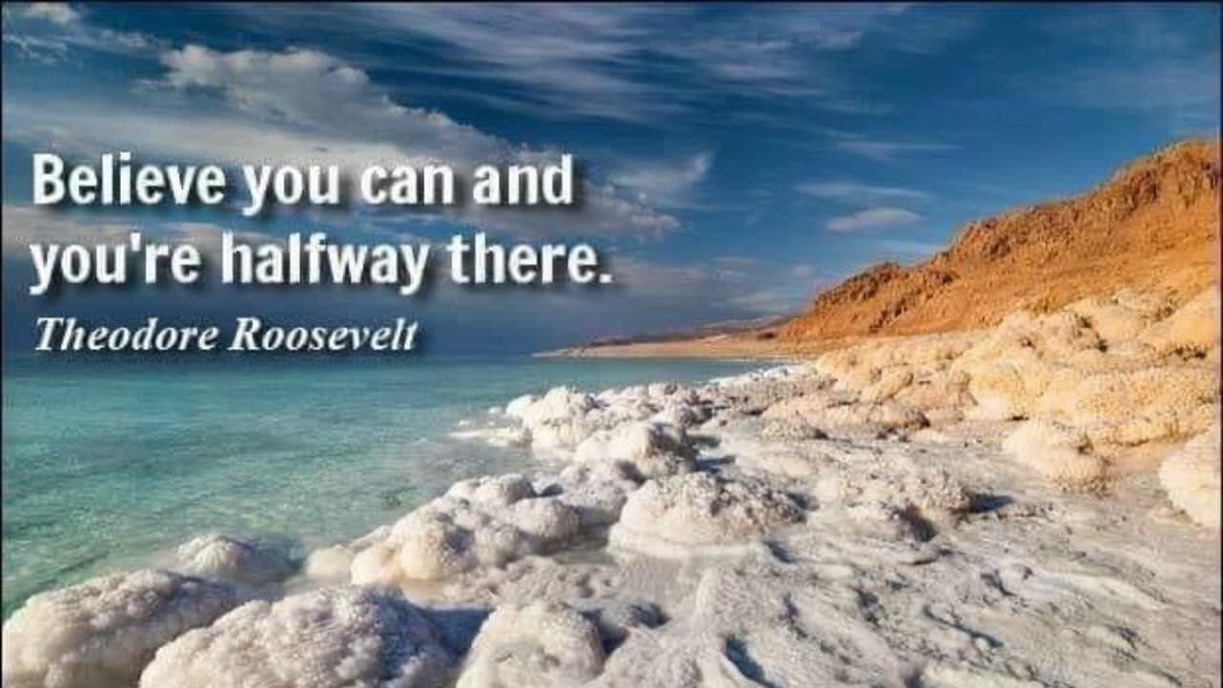
5
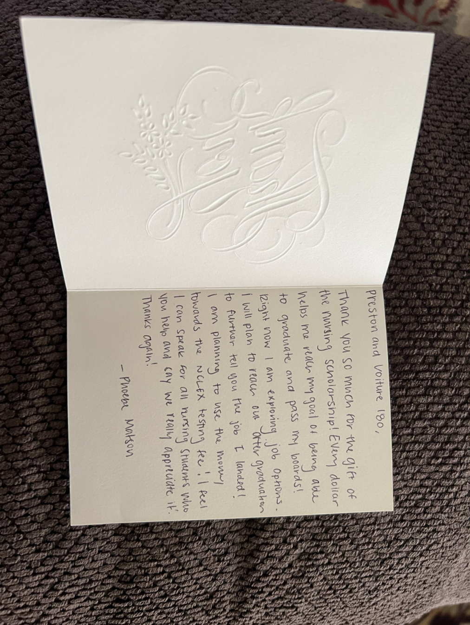
Thank you from Nursing Student Phoebe Matson
The above letter is from Nursing Student Phoebe Matson who our Voiture 180 gave a Nursing Scholarship to.
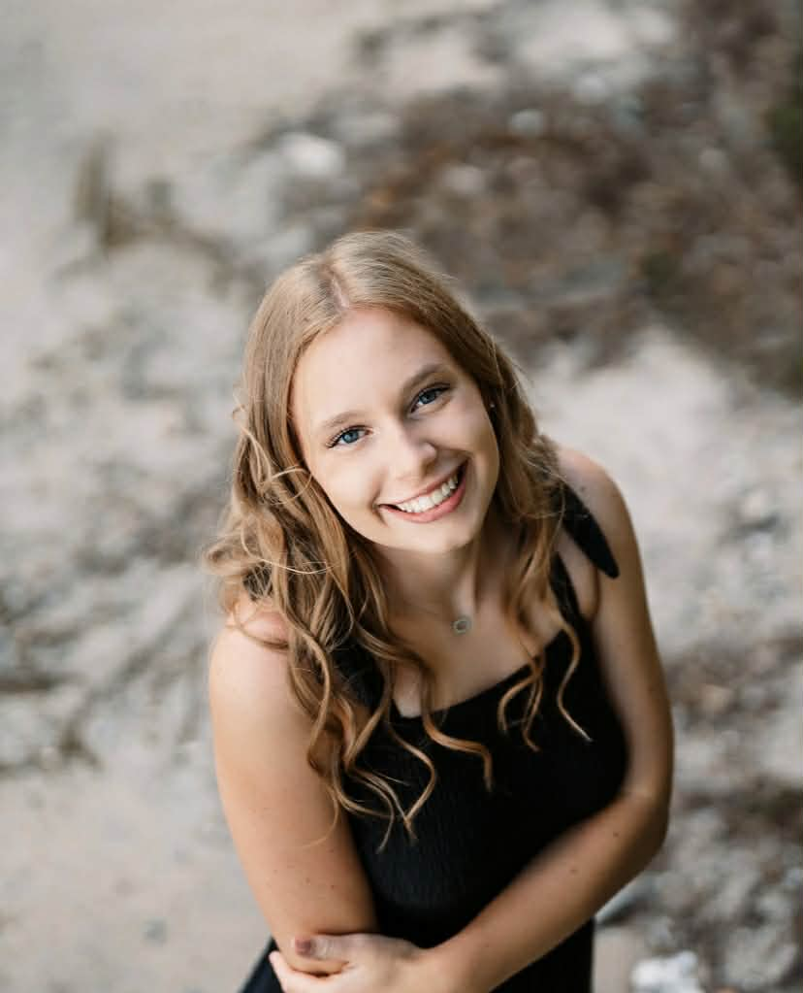
Phoebe Matson

6
DAKOTA 40 and 8 er JANUARY 2026
Would all of you write us and answer the following questions.
What does “HONOR SOCIETY OF
AMERICAN VETERANS” mean to you?
The above short article was in our JANUARY 2026 DAKOTA 40 and 8 NEWSLETTER sent to over 100 Voyageurs.
We received one letter from a concerned Voyageur, that follows. We would still like to hear from you for our future DAKOTA NEWSLETTERS.

LETTER RECEIVED BY A VOYAGEUR
Preston, That is an outstanding issue and you are to be commended for it. I appreciate you including me on your disbursement list.
Thanks for the kind words and your agreement with what I believe is happening in the Forty and Eight. I am flattered that you want to use that message in your bulletin and I am happy for you to do so.
In answer to your question of What does the Honor Society of the 40 and 8 mean to me, I will sum it up in this manner……I believe now, just as I did 30 some years ago that the mission and work of the Forty and Eight is worthy, honorable and has great value to the veterans and their communities. HOWEVER, in the last several years the administration of the organization has not done an honorable job in conducting business and it has become a “Good Ole
Boy Club” catering only to their own selected group and their interests. Some of the traditions and even some constitutional issues have been ignored to suit their personal needs.
So it seems as if “The Honor Society of American Veterans” has been paying a lot less attention to the honor lately and therefore tarnishing that motto.
This is just my opinion from my own experiences and observations and as I said earlier I believe 100% in the Forty and Eight and I still love it today, but I find it very difficult to support a group autonomous “leaders” interested more in self recognition and authority than the greater good of the organization.
I will continue to keep up the good fight because I believe the right thing to do may not always be the right thing personally but it is still the RIGHT THING, but I feel the organization has much more worth than what these fools can say. Maybe someone will read your bulletin and agree and be bold enough to support the claims made in the article. If that were the case, I would feel as if I accomplished something no matter how small.
You take care of yourself and say "hi" to Iryna, and God Bless you and keep working to make the Grand du South Dakota a genuine 40 & 8 Grand Voiture.
God Bless you Preston
We do our best with our few active members in Locale FALLS Voiture 180. We give NURSES SCHOLARSHIPS. do the 40 and 8 FLAG PROGRAM in several schools, set up POW/MIA TABLE on the 3rd Friday in September in a dozen or more restaurants for REMEMERENCE DAY, put on VETERANS DAY PROGRAMS in schools.
I would like to add that when I ran for Chef de Chemin de Fer, my good friends told me I would not win. I asked why they would say that and they said “you do not agree with the way they do things” and if the voyageurs that run the 40 and 8 don’t want you don’t win. AND I DID NOT WIN.I also do not like all the Grands and Locales sitting on thousands of dollars, I strongly believe this money raised by voyageurs who have been called to report to supreme Commander of the Universe and have taken their places in the ranks of the unnumbered dead should be spent in the communitees it was raised in. Preston Olson

