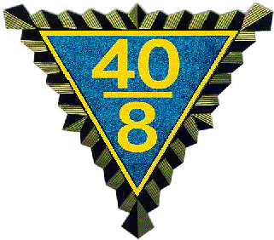
Official Call to 2026 Spring Grand Cheminot
April 25th, 2026
Crossroads Chapel
1049 JC PKWY
(Across the street from Hotel)
Bloomington, IL.

HEADQUARTERS MOTEL
Holiday Inn Express, Bloomington IL.
1031 Wylie Dr. 309-820-9990
CHEMINOT MEETING 9:30 am
Meeting to be held at the Crossroads Chapel
1049 JC Pkwy (across from Hotel)
Directions available in Hospitality room
Cheminot Meeting 1:00 pm.

Directions available at Motel.

In conformity with the Grande Voiture du Illinois constitution, the Spring Grand Cheminot is hereby called to convene as stated above. Only those designated are eligible for reimbursement, as per Grande Voiture Constitution.

All Voyageurs in good standing for the current year are invited to attend. Voyageurs must present their current year membership card to the Grand Guard de la Porte before being admitted to the business session, know the Nationale Password and wear your chapeau. Those on official call and eligible for reimbursement may pick up their voucher at the registration table at the Headquarters hotel.
Called are: Grand Cheminots of all Grand d’ Illinois Districts. Also called are Grand Chef de Gare, Gerald “JT” Terando, Grand Chef de Train, Robert Dettmann, Cheminot National Todd Latham, Grand Correspondant, Wally Hammond, Grand Commissaire Intendant, Todd Latham, Grand Avocat, Todd Latham, Grand Aumonier, Ralph Rounds, Aide de Camp, Celeste Latham, Grand Guard de la Porte, Tom Mlynek, Grand Lampiste, Robert Przybylinski, Grand Commis Voyageur, Peter Hirt, Grand Organizer North, Dwight Moss, Grand Organizer South, Ralph Rounds, Grand Conducteur, Tom Mlynek, Budget Ways and Means, Verlin Funkhouser, Dir. Thomas Mlynek, Committee, Grand Audit Directeur, Todd Latham, Committee, Verlin Funkhouser, Tom Mlynek, Robert Przybylinski, Resolutions, Celeste Latham, Nurses Procurement, John Cole Dir., Committee, Dr. John Chaellier, Le Editor/Web master, Robert Dettmann
ANY OTHERS SUBJECT TO CALL ARE AT THE DISCREATION OF THE GRAND CHEF
All Voyageurs in good standing for the current year are invited to attend. Voyageurs must present their current year membership card to the Grand Guard de la Porte before being admitted to the business session, know the Nationale Password and wear your chapeau. Those on official call and eligible for reimbursement may pick up their voucher at the registration table at the Cheminot meeting.

Grand Correspondant Grand Chef De Gare
Wally Hammond Gerald Terando

