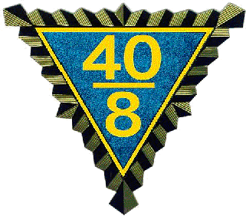 

**Call to 2025 Spring Grand Cheminot**

**April 25 & 26, 2025**

**Crossroads Chapel**

**1049 JC PKWY**

**(Across the street from Hotel)**

**Bloomington, IL.**

**HEADQUARTERS MOTEL**

**Holiday Inn Express, Bloomington IL.**

**1031 Wylie Dr. 309-820-9990**

**CHEMINOT MEETING 10:00 am**

**Meeting to be held at the Crossroads Chapel**

**1049 JC Pkwy (across from Hotel)**

**Directions available in Hospitality room**

**Cheminot Meeting 1:00 pm.**

**Directions available at Motel.**

**In conformity with the Grande Voiture du Illinois constitution, the Spring Grand Cheminot is hereby called to convene as stated above. Only those designated are eligible for reimbursement, as per Grande Voiture Constitution.**

All Voyageurs in good standing for the current year are invited to attend. Voyageurs must present their current year membership card to the Grand Guard de la Porte before being admitted to the business session, know the Nationale Password and wear your chapeau. Those on official call and eligible for reimbursement may pick up their voucher at the registration table at the Headquarters hotel.

**Called are: Grand Cheminots of all Grand d’ Illinois Districts. Also called are Grand Chef de Gare, Todd Latham, Grand Chef de Train, Gerald (JT) Terando, Cheminot National Celeste Latham, Grand Correspondant, Wally Hammond, Grand Commissaire Intendant, Victor Martinka, Grand Avocat, Robert Cearlock, Grand Aumonier, Ralph Rounds, Aide de Camp, Frank Beierlotzer,** **Grand Guard de la Porte, Rob Dettman, Grand Lampiste Robert Przybylinski, Grand Organizer North, Dwight Moss, Grand Conducteur, Chris Hinton, Budget Ways and Means, Verlin Funkhouser, Dir. Thomas Mlynek, Committee, Grand Audit Directeur,, Robert Przybylinski. Committee, Todd Latham, Mike Mittelstaedt, Resolutions, Celeste Latham, Nurses Procurment, John Cole Dir., Committee, Dr. John Chaellier, Le Editor/Web master, Robert Cearlock**

**ANY OTHERS SUBJECT TO CALL ARE AT THE DISCREATION OF THE GRAND CHEF**

**All Voyageurs in good standing for the current year are invited to attend. Voyageurs must present their current year membership card to the Grand Guard de la Porte before being admitted to the business session, know the Nationale Password and wear your chapeau. Those on official call and eligible for reimbursement may pick up their voucher at the registration table at the Cheminot meeting.**

**Grand Correspondant Grand Chef De Gare**

**Wally Hammond Todd Latham**