Greetings Chevaliers!
First of all, let me apologize for my slow actions. It’s been a rough year in the Cearlock family. I won’t boar you with details and hopefully will be able to pick up the pace the rest of the year.
The Blue Chevaliers on the other hand has had a great 3 Quarters. As of this writing we are now 275 members strong and growing. I am also impressed by the fact that 61 of our members are LIFE members!
I am extremely grateful to our new National PR Directeur, Renny Keagle for picking up the ball and running with it during my down time.
He made our presentation to the Forty & Eight Law Officer of the Year, Deputy Tyler Post of $2,00.00 [or I should say, his wife] during the Business Session.
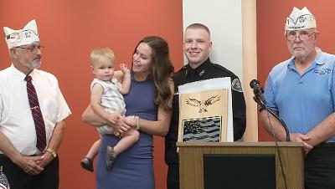
I am delighted to tell you that next year’s award is already funded.
We need to seek out Officers and Organizations for recognition this year. We have retired Officers as members who I hope will link up with their colleagues and find great candidates.
The Committee is currently looking at the financial outlook and is considering raising the dues for renewal. The current economic environment does not bode well for any of us as the $2.00 renewal will no longer cover the cost of postage and materials. Some confusion about this internal discussion caused some of you at the Nationale Promenade to pay $10.00 to renew your membership for 2023. I am sorry for the confusion and will refund you the $8.00 if you email me a request. The Project is sufficiently funded at this time to budget for 2023. However, we will have to consider raising renewal dues for 2024.

Robert “OB1” Cearlock
Project Manager

Wow, what a great Promenade Nationale at Green Bay. The P.A.L.S. and Blue Chevalier table was very busy with renewals and signing up new members. Of particular note was the activity and interest in the Blue Chevalier Project. I was amazed at the number of paid-up-for-life that were signed up. Congratulations to all those support this great project.
As I stated on the floor at Nationale, there are 900,000 law officers in the United States. We in La Société have the honor of selecting one for our Law Officer of the Year. The Blue Chevalier Project allows any Blue Chevalier member, at the grass-roots level, to go out into our communities and select an appropriate law officer from the remaining 899,999.
There are a wide variety of types of law enforcement officers and organizations. The Blue Chevalier Award is not limited to just a single officer, but a law enforcement unit or organization may also be recognized. I am looking at our regional/sector Border Patrol unit dealing with the massive immigration problem here at our border and a National Guard Unit recently back from Guantanamo Bay also helping and assisting with disasters in our state.
The Blue Chevalier Project is a way to fight back against those that want to de-fund the police and reduce the positive impact and safety net that law enforcement provides – as they enter into harm’s way every day. From a public relations standpoint, we need to support this effort in the Forty and Eight which also gains support and recognition for La Société.

Renslar “Renny” Keagle
Public Relations Directeur, Nationale

A VERY SPECIAL THANK YOU TO THE ORGANIZATIONS AND MEMBERS WHO HAVE MADE GENEROUS DONATIONS TO THE BLUE CHEVALIERS! IN THIS ECONOMY IT IS A SIGN OF TRUE DEDICATION TO OUR MISSION STATEMENT.

IMPORTANT NOTE!
You will be able to read the “Roll Call” and the latest Membership reports online at http://www.illfortyandeight.com/ (SELECT THE Blue Chevaliers tab)

Sarcastic Al Says:
Always remember that you’re unique. Just like everyone else.

AWARD PROPOSAL
The following |  |  |  | Law Officer |  |  | Law Enforcement Organization
 | NAME:
 |  | INDIVIDUAL OFFICER OR ORGANIZATION
 | ADDRESS:
 |  | CITY: |  |  |  |  |  | St.: |  |  | ZIP:
 |  | ADDRESS OF THE ORGANIZATION FOR OFFICER OR ORGANIZATION
TYPE OF AWARD:
 | OUTREACH PROGRAM |  | VALOR OR HEROISM |  | INDIVIDUAL COMMUNITY RELATIONS |  | OTHER  (explain in narrative)
PROPOSAL NARRATIVE:
(explain the reason you feel this Indiviual Law Officer or Law Enforcement Organization should receive recognition)
ADD ADDITIONAL PAGES AS NECESSARY.
WHO WILL MAKE THE PRESENTATION? _____________________________________________
WILL MEDIA BE PRESENT? ________
WIIL YOU SEND PHOTOS TO THE PROJECT OF THE PRESENTATION?_________________
MEMBER MAKING THIS PROPOSAL:
NAME:
ADDRESS: | STREET: |  | CITY: | ST: | ZIP:
PHONE: |  | EMAIL:
SEND PHOTOS AND/OR ARTICLES CONCERNING THE PRESENTATION TO:
Robert Cearlock, 7 Lawnwood Dr. Jackson, TN, 38305 or cearlock@aol.com
MEMBER MAKING PRESENTATION IF NOT THE SAME : Award Certificate will be sent here
NAME:
ADDRESS: |  | STREET: |  | CITY: | ST: | ZIP:
PHONE: |  |  | EMAIL:
 | BLUE CHEVALIERS MEMBER SHIRT ORDER FORM
Price = $32.00
SHIRT SIZE: SMALL, MEDIUM, LARGE, XL [circle one]
LARGER SIZES:
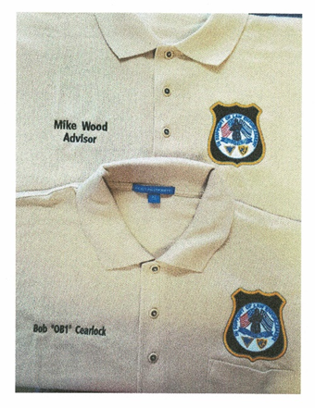
Price = $34.00 for XXL,
$36.00 for XXXL,
$40.00 for XXXXL
Pocket [K5001] __ Pocketless [K500] ___
NAME/TITLE ON SHIRT: PLEASE print clearly!
2 lines

ORDER TOTAL: $
Make check to 40/8 BLUE CHEVALIERS
And SEND FORM & PAYMENT TO
40/8 BLUE CHEVALIERS
c/o Robert Cearlock
7 LAWNWOOD DR.
JACKSON, TN 38305
SHIP SHIRT TO:
 | NAME:
 | ADDRESS:
 | CITY: |  |  |  | ST: |  | ZIP;
AMOUNT ENCLOSED:
MAIL WITH CHECK MADE PAYABLE TO THE
“ 40/8 BLUE CHEVALIERS” TO:
 | 40/8 Blue Chevaliers  c/o Robert Cearlock,  7 Lawnwood Dr.  Jackson, TN, 38305

